# Introduction

1. 老师的自我介绍：
   1. via Email, zhangjg@sustech.edu.cn（欢迎练习老师了解更多的课程相关内容）
   2. My research interests in AI:
      1. • Computer Vision
      2. • Pattern Recognition and multimodal analysis
         1. • Object recognition
         2. • Image segmentation
   3. • Medical Image Analysis segmentation
      1. • Multimodal Brain lesion (tumour)
   4. • Machine Learning
      1. • OOD, Calibration, Uncertainty
2. Module content（模块内容）
   1. MLP（多层感知机）（前向传播速度和反向哪一个更快？）

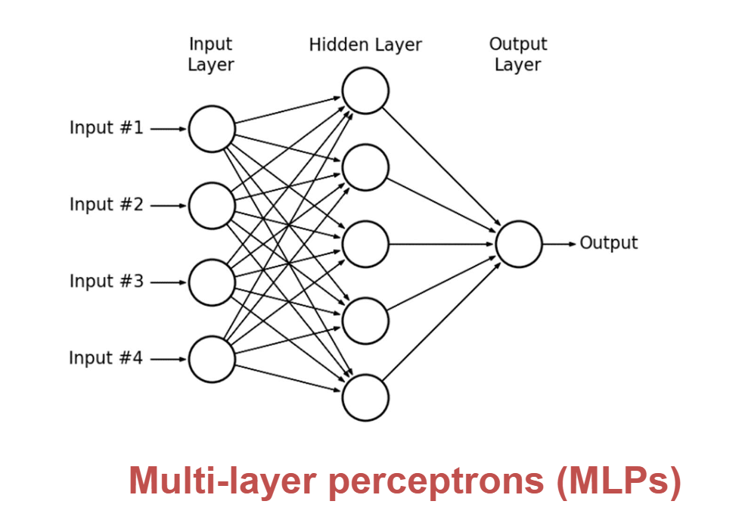

* 1. Convolutional neural networks (CNNs)
  2. Recurrent neural networks (RNNs)
  3. Generative adversarial networks (GANs)
  4. Deep learning on graphs
  5. Deep reinforcement learning

1. 书籍推荐
   1. Main textbook:
   2. • Goodfellow, Ian, Yoshua Bengio, Aaron Courville. Deep learning. Vol. 1. Cambridge: MIT press, 2016.
   3. https://www.deeplearningbook.org/
   4. • Other recommended books:
   5. • Chollet, Francois. Deep learning with python. Manning Publications Co., 2017.
   6. • Nielsen, Michael A. Neural networks and deep learning. Vol. 25. USA: Determination press, 2015.
2. What is Deep Learning?

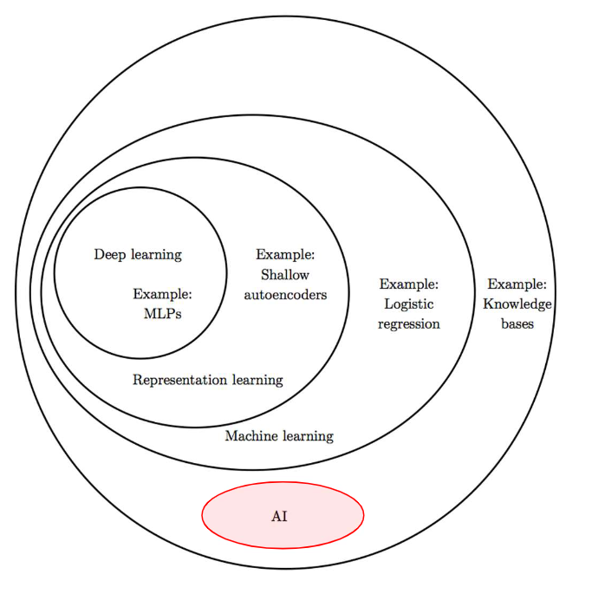

1. Artificial neurons（人工神经元）

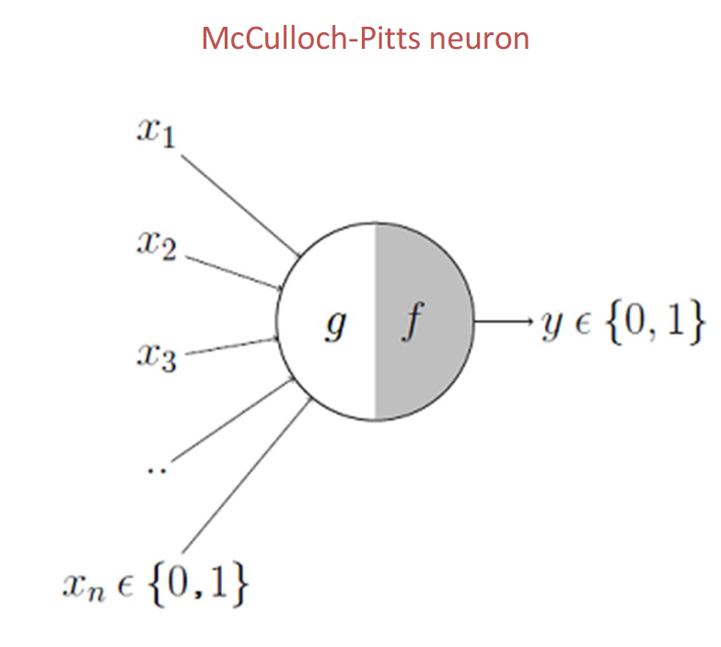

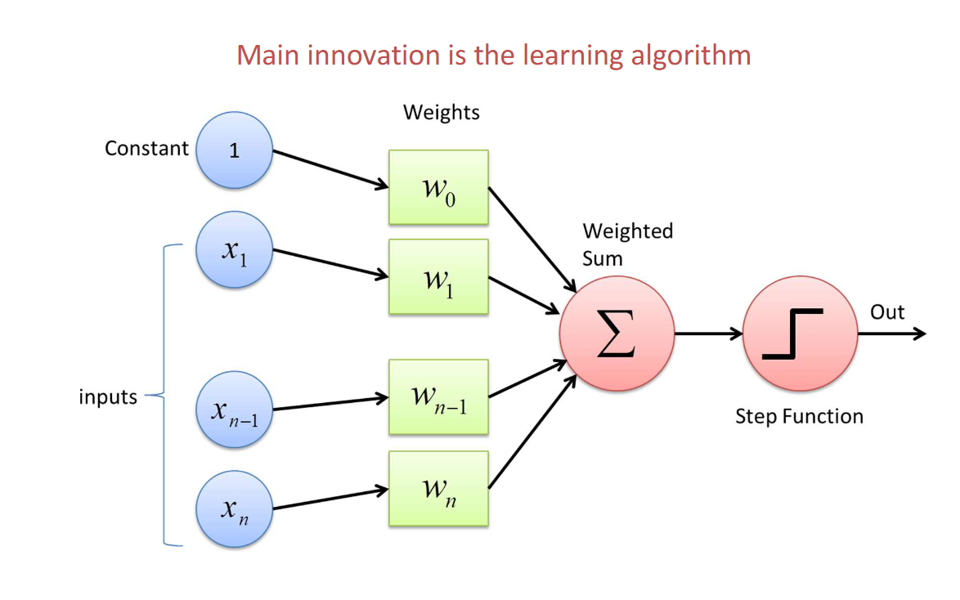

1. How Can I learn deep learning well? By ChatGPT

